Un cappuccino per un pc

Tra i più richiesti


Intel Celeron Mobile 370 1.5 Ghz Ram 512mb/Hd60 Gb / Dvd Double Layer / Lan-Modem / Windows Xp Home / Intel Graphics Media Accellerator 900 128mb condivisi Schermo 14,1” Wide screen / 3Usb (Usb 2.0) Peso 2,35 Kg / Dimensioni (L x A x P) " 33.4cm 3,5cm - 24,4cm"

<SPAN style="FONT-SIZE: 10pt; FONT-FAMILY: Arial">aAAAMD Sempron 3000+ / Ram 256 Mb / Hd 60Gb - DVD Dual / </SPAN><SPAN style="FONT-SIZE: 10pt; FONT-FAMILY: Arial"></SPAN><SPAN style="FONT-SIZE: 10pt; FONT-FAMILY: Arial"> </SPAN><SPAN style="FONT-SIZE: 10pt; FONT-FAMILY: Arial">Scheda video 128 Mb - monitor 15,4”- 3 porte USB 2.0 - Porta Firewire -uscita VGA - modem 56K </SPAN>- <SPAN style="FONT-SIZE: 10pt; FONT-FAMILY: Arial"></SPAN><SPAN style="FONT-SIZE: 10pt; FONT-FAMILY: Arial"></SPAN><SPAN style="FONT-SIZE: 10pt; FONT-FAMILY: Arial">Ethernet 10/100 Mbps / wireless LAN 802.11b/g. Windows XP Home </SPAN>
<SPAN style="FONT-SIZE: 10pt; FONT-FAMILY: Arial"> </SPAN>

Con 512Mb di Ram

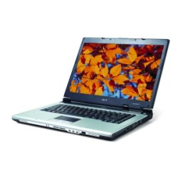
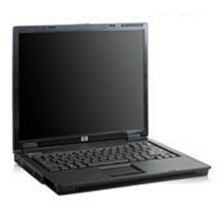

TM 2423WXM

ASPIRE 3004WLMI 4062WLMI

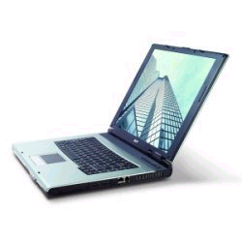

Con scheda lan wi-fi PCMCIA
D-Link 22Mbps + 9,00 euro
Con scheda lan wi-fi PCMCIA
3Com 54Mbps + 19,00 euro


<SPAN style="FONT-SIZE: 10pt; FONT-FAMILY: Arial">Intel Centrino M 740 da 1,73 GHz –
Ram 512 Mb – Hd 60Gb - DVD Dual
</SPAN><SPAN style="FONT-SIZE: 10pt; FONT-FAMILY: Arial"></SPAN><SPAN style="FONT-SIZE: 10pt; FONT-FAMILY: Arial"> </SPAN><SPAN style="FONT-SIZE: 10pt; FONT-FAMILY: Arial">Scheda video Intel 128 Mb condivisa - monitor "15,4 pollici"- 3 porte USB 2.0 - Porta Firewire -uscita TV e VGA - modem 56K </SPAN>- <SPAN style="FONT-SIZE: 10pt; FONT-FAMILY: Arial"></SPAN><SPAN style="FONT-SIZE: 10pt; FONT-FAMILY: Arial"></SPAN><SPAN style="FONT-SIZE: 10pt; FONT-FAMILY: Arial">Ethernet 10/100 Mbps / wireless LAN 802.11b/g. Windows XP Professional </SPAN>
<SPAN style="FONT-SIZE: 10pt; FONT-FAMILY: Arial"> </SPAN>

Intel Centrino 740 1,73ghz,Ram 512 Mb Hard Disk 60 Gb /Peso 2.7kg
Masterizzatore DVD, Schermo 15” Xga 1024 x 768 / Connettività Data/Fax Modem 56-K / Lan 10/100 / Wireless 802.11b/G / Windows Xp Home
Scheda Grafica 128 Mb (Condivisa)

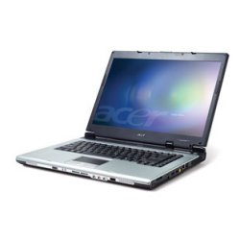
HP COMPAQ
NX 6110C

TM 4062WLMI

GS SISTEMI SRL CORSO D’ITALIA 140 87100 COSENZA TEL. 0984 35352 www.gs-sistemi.it

<SPAN style="FONT-SIZE: 10pt; FONT-FAMILY: Arial">Intel Centrino 1,8 GHz - RAM 512 MB - hd80gb - DVD Dual - </SPAN><SPAN style="FONT-SIZE: 10pt; FONT-FAMILY: Arial"></SPAN><SPAN style="FONT-SIZE: 10pt; FONT-FAMILY: Arial"> </SPAN><SPAN style="FONT-SIZE: 10pt; FONT-FAMILY: Arial">Scheda video ATI Radeon 128 Mb - monitor "15 pollici"-
3 porte USB 2.0 - Porta Firewire-uscita TV - modem 56K - Bluetooth </SPAN>
<SPAN style="FONT-SIZE: 10pt; FONT-FAMILY: Arial"></SPAN><SPAN style="FONT-SIZE: 10pt; FONT-FAMILY: Arial"></SPAN><SPAN style="FONT-SIZE: 10pt; FONT-FAMILY: Arial">Ethernet 10/100 Mbps / wireless LAN 802.11b/g. Windows XP Professional </SPAN>
<SPAN style="FONT-SIZE: 10pt; FONT-FAMILY: Arial"> </SPAN>

<SPAN style="FONT-SIZE: 10pt; FONT-FAMILY: Arial">Intel Centrino Duo T2300 1,66 GHz - Ram 512 MB - HD80gb - DVD Dual - </SPAN><SPAN style="FONT-SIZE: 10pt; FONT-FAMILY: Arial"></SPAN><SPAN style="FONT-SIZE: 10pt; FONT-FAMILY: Arial"> </SPAN><SPAN style="FONT-SIZE: 10pt; FONT-FAMILY: Arial">Scheda video 128 Mb - monitor 15" XGA
3 porte USB 2.0 - Porta Firewire - Modem 56K - </SPAN><SPAN style="FONT-SIZE: 10pt; FONT-FAMILY: Arial"></SPAN><SPAN style="FONT-SIZE: 10pt; FONT-FAMILY: Arial"></SPAN><SPAN style="FONT-SIZE: 10pt; FONT-FAMILY: Arial">Ethernet 10/100 Mbps / Wireless LAN 802.11b/g. Windows XP Home
<SPAN style="FONT-SIZE: 10pt; FONT-FAMILY: Arial"> </SPAN>

TM 8005LMI

TM 4202LMI

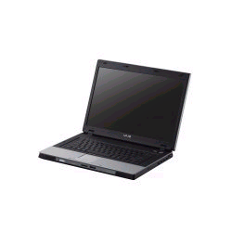

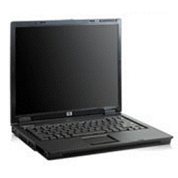
Centrino Pentium M 760 (2,0 Ghz) Ram 1 Gb (2*512mb) Hard Disk 100gb Dvd-Dual Layer / Schermo 15,4” Wsxga /Modem 56k V.92 /Ethernet 10/100 Mbps / Microsoft Windows Xp Professional /Integrated Intel Pro/Wireless 2200bg Network Connection 802.11b/G Wi-Fi Certified/ Ati X700 128mb Dedicata, 3x Usb 2.0, / Bluetooth / Peso 2,86kg
Dimensioni 363 (L) x 265 (P) x 34,3 (A) Mm

Pentium M Processor 740 (1.73 Ghz) Ram 1Gb /Hd100 Gb /Dvd Double L.
Schermo 17” Wxga (1440 x 900) Lan-Modem-Wireless-Bluetooth

Windows Xp Home Service Pack 2 Ati X700 256mb 5 Usb (Usb 2.0) Monitor (Vga) Antenna TV Dimensioni (L x A x P) " 40,2 x 28,6 x 4,07cm" Peso 3,8 Kg

ASPIRE 9502WSMI

TM 8104WLMI

!!!!!!!! Oltre a questi notebook presso di noi puoi trovare ulteriori marche e modelli !!!!!!!!

GS SISTEMI SRL CORSO D’ITALIA 140 87100 COSENZA TEL. 0984 35352 www.gs-sistemi.it

